**COP6616 Parallel Computing**

**Instructor: Scott Piersall**

**Fall 2024**

**Assignment 3**

**README.MD**

***echo "PATH=/usr/local/cuda/bin/:$PATH" >> ~/.bash_profile***

***source ~/.bash_profile***

***sudo apt install libpng-dev***

***OR (NON-SUDO)***

***wget http://prdownloads.sourceforge.net/libpng/libpng-1.6.44.tar.xz***

***tar xf libpng-1.6.44.tar.xz***

***cd libpng-1.6.44***

***./configure --prefix=$HOME/lib/libpng***

***make***

***make install***

***\*q2\****

***nvcc -lm q2.cu -o q2***

***./q2 1000000 100***

***\*q3\****

***nvcc -lm -lpng q3.cu -o q3***

***OR (NON-SUDO)***

***nvcc -lm q3.cu -o q3 -L$HOME/lib/libpng/lib -I$HOME/lib/libpng/include -lpng***

***./q3***

***\*q4\****

***nvcc -lm q4.cu -o q4***

***./q4 1000 1000 1000 10***

1. **Short Answer Questions (14 points).**

1). What is the difference between data spatial locality and temporal locality?

**In spatial locality, items being accessed are close to one another in memory. It’s why we retrieve memory in blocks, because items next to each other in memory are likely to be accessed in the same time frame. In temporal locality, we’re reusing items in cache multiple times. This leads to paging paradigms like FIFO (first in, first out) or LRU (least recently used) for caching, where we fill the cache by replacing the oldest or least recently used element.**

2). In the MPI Gather routine, does the root contribute data?

**Yes, the root contributes data in MPI_Gather.**

**Source:** [**https://rookiehpc.org/mpi/docs/mpi_gather/index.html**](https://rookiehpc.org/mpi/docs/mpi_gather/index.html)

3). For the following MPI code, decide whether there is/are any potential problem(s) with it. If there are problems, please fix them.

if (rank =0){

MPI_Barrier(…);

} else {

do something;

}

*/\*\**

*\* if (rank = 0) { should be if (rank == 0) {*

*\* MPI_Barrier(...) should be called by all processes, not just rank 0*

*\* The code as written will cause a deadlock because rank 0 will be waiting*

*\* for all other processes to reach the barrier, but the other processes will*

*\* not reach the barrier because they are not calling MPI_Barrier(...).*

*\**

*\** **SOURCE:** *https://rookiehpc.org/mpi/docs/mpi_barrier/index.html*

*\*/*

MPI_Barrier(...);

if (rank == 0) {

*// do a thing with rank 0 if you would like*

} else {

*// do something with all other ranks*

}

4). In CUDA programs, if we compare “structure of arrays” and “array of structures”, which one is offers better memory access performance? WHY?

**For an example structure:**

**struct** Particle {

**double** posx, posy, posz;

**double** velx, vely, velz;

**double** mass;

};

**Structure of Arrays memory layout would look like:**

posx = {0.1, 0.2, 0.3, ...}

posy = {0.4, 0.5, 0.6, ...}

posz = {0.7, 0.8, 0.9, ...}

velx = {1.0, 1.1, 1.2, ...}

vely = {1.3, 1.4, 1.5, ...}

velz = {1.6, 1.7, 1.8, ...}

mass = {2.0, 2.1, 2.2, ...}

**Array of Structures memory layout would look like:**

particles = {

    {0.1, 0.4, 0.7, 1.0, 1.3, 1.6, 2.0},

    {0.2, 0.5, 0.8, 1.1, 1.4, 1.7, 2.1},

    {0.3, 0.6, 0.9, 1.2, 1.5, 1.8, 2.2},

    ...

}

**The Structure of Arrays provides spatial locality. In this example, in order to perform operations on a given variable in the structures, we can either access contiguous memory with SoA or access a double, skip the memory space for six doubles, access the next double, etc. with AoS. SoA also allows for “coalesced memory access” where consecutive threads access consecutive memory addresses.**

5). Discuss the difference between the following GPU memory: global, local, shared, texture, and constant. Which one is the fastest?

|  |  |
| --- | --- |
| Memory Type | Qualities |
| Global | Accessible by all GPU threads, largest, high latency (slow) |
| Local | Private to each GPU thread, same latency as global, temporary storage of register spillover variables |
| Shared | Accessible by all GPU threads WITHIN THE SAME BLOCK, low latency, **FASTEST MEMORY FOR WITHIN BLOCK ACCESS UNLESS THERE IS A BANK CONFLICT** |
| Texture | Cached memory optimized for 2D spatial locality |
| Constant | Cached memory accessible by all threads, optimized for broadcasting to multiple threads within one warp, slower for unique access per thread |

Sources:

<https://www.arccompute.io/arc-blog/gpu-101-memory-hierarchy#:~:text=Global%20Memory:%20Size:%20Global%20memory%20is%20the,input%20data%2C%20output%20data%2C%20and%20global%20constants>.

<https://carpentries-incubator.github.io/lesson-gpu-programming/global_local_memory.html>

<https://docs.nvidia.com/gameworks/content/developertools/desktop/analysis/report/cudaexperiments/kernellevel/memorystatisticslocal.htm>

<https://developer.nvidia.com/blog/using-shared-memory-cuda-cc/#:~:text=Access%20to%20shared%20memory%20is,mechanism%20for%20threads%20to%20cooperate>.

6). If shared memory in a GPU is defined and used in the following way, under what scenario about the variable “s”, is there a bank conflict? Under what scenario is there no bank conflict? Why?

__shared__ float shared[16];

float foo = shared[baseIndex + s * threadIdx.x];

**A bank conflict occurs when multiple threads in a warp try to access different addresses that map to the same memory bank of shared memory.**

**The shared memory is divided into 32 banks. We can guarantee no bank conflicts if we use a stride of 32 (s = 32).**

**If we set stride to 2 (s = 2), we would have a one-way bank conflict from threads 0 and 16 (if we had that many threads):**

**shared[baseIndex + s * threadIdx.x];**

**shared[baseIndex + (2 * 0) % 32] = shared[baseIndex + 0]**

**shared[baseIndex + (2 * 16) % 32] = shared[baseIndex + 0]**

**If we set the stride to 16, which feels intuitive, we actually end up with two-way conflict between banks 0 and 16.**

**shared[baseIndex + (16 * 0) % 32] = shared[baseIndex + 0]**

**shared[baseIndex + (16 * 1) % 32] = shared[baseIndex + 16]**

**shared[baseIndex + (16 * 2) % 32] = shared[baseIndex + 0]**

**shared[baseIndex + (16 * 3) % 32] = shared[baseIndex + 16]**

**shared[baseIndex + (16 * 4) % 32] = shared[baseIndex + 0]**

**…**

**The array bounds don’t matter, the bank size and stride alignment do.**

7). If shared memory in GPU is defined and used in the following way, what kind of bank conflict (such as 2-way, 4-way, 8-way) does it have? Why?

__shared__ **char** shared[];

foo = shared[baseIndex + threadIdx.x];

**Each char maps to a bank, so unless we have a number of threads that is <=32, the number of banks, we’re going to have bank conflicts. If baseIndex isn’t 0, we can also wrap around and have bank conflicts. Knowing the size of shared would provide a clearer answer, but given a typical access where baseIndex == 0, there is a high potential to have each thread have conflicts if our number of threads exceeds 32.**

1. **(15 points)** Please write **a CUDA program** to compute the Euclidean distance, similar to the problem in assignment 2.

You may design your code using the following steps:

* Declare the arrays (host and device). All arrays should be dynamically allocated; the host arrays can be allocated either with malloc or new, while the device arrays should be allocated with cudaMalloc.
* Print the number of CUDA-enabled hardware devices attached to the system by calling cudaGetDeviceCount.
* Print at least 3 interesting properties of Device 0, including the device name, by calling cudaGetDeviceProperties. The first argument to this function is a pointer to a struct of type cudaDeviceProp.
* Calls InitArray to initialize the host arrays. InitArray initializes an integer array with random numbers within a fairly small range (0 to 99).
* Calls cudaMemcpy to copy the host input arrays to the device.
* Calls the CUDA kernel, which computes the square of the difference of the components for each dimension, reduce all the elements of the output array in parallel (you may need to investigate how to implement an efficient parallel reduce in CUDA), and takes the square root of the sum.

Run experiments using varying size of inputs. Graph and discuss the speedup provided by the GPU/CUDA implementation over varying input sizes. Is there an input size where the speedup stops?

***Number of CUDA-enabled devices: 1  
Device Name: NVIDIA GeForce GTX TITAN X  
Compute Capability: 5.2  
Total Global Memory: 12792627200 bytes  
Shared Memory Per Block: 49152 bytes  
Registers Per Block: 65536***

|  |  |  |  |  |  |  |
| --- | --- | --- | --- | --- | --- | --- |
| **Vector Dimension** | **Number of Tests** | **Average Serial Time (s)** | **Average Parallel Time (s)** | **Theoretical Speedup (Amdahl’s Law)** | **Actual Speedup** | **Speedup Ratio (% of Theoretical)** |
| **1000** | **100** | **0.000002** | **0.000477** | **1.998002** | **0.004609** | **0.230667** |
| **100000** | **100** | **0.000218** | **0.000668** | **1.999980** | **0.326267** | **16.313530** |
| **1000000** | **100** | **0.002178** | **0.002671** | **1.999998** | **0.815509** | **40.775493** |
| **10000000** | **100** | **0.021802** | **0.018909** | **2.000000** | **1.152992** | **57.649604** |
| **100000000** | **100** | **0.217731** | **0.107885** | **2.000000** | **2.018177** | **100.908847** |
| **110000000** | **100** | **0.239486** | **0.116823** | **2.000000** | **2.049986** | **102.499319** |
| **120000000** | **100** | **0.261313** | **0.126060** | **2.000000** | **2.072920** | **103.646001** |
| **200000000** | **100** | **0.435498** | **0.199160** | **2.000000** | **2.186681** | **109.334049** |
| **500000000** | **100** | **1.088922** | **0.477112** | **2.000000** | **2.282322** | **114.116090** |
| **750000000** | **100** | **1.622030** | **0.725269** | **2.000000** | **2.236453** | **111.822659** |

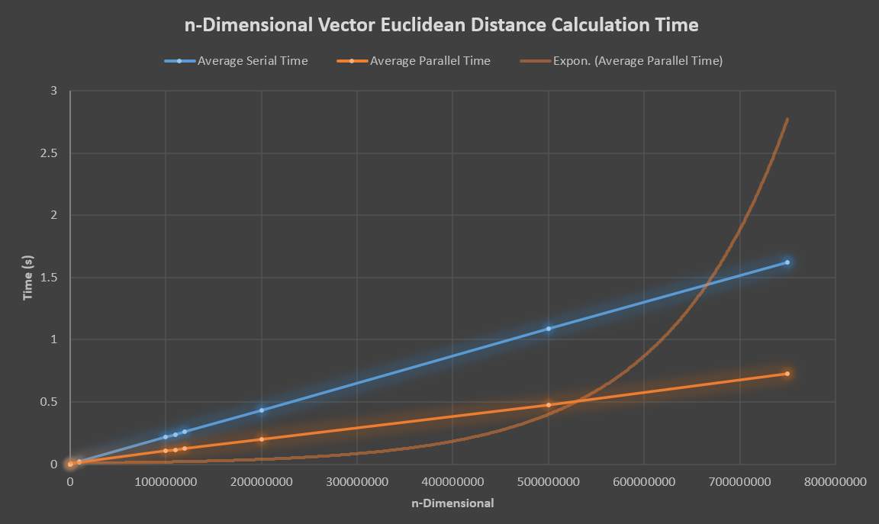

**Amdahl’s requires me to guess at the parallelizable fraction of the work, which is why the percentage ultimately exceeds 100%. That data wasn’t asked for in this assignment, so I did not bother adjusting it. The speedup ratio did eventually drop off, and an exponential trend line does show that while the rate of time increase is slower than the same calculations performed serially (that trend line distorts the graph), eventually we’re going to slow down. As with other parallel calculations, the time required to push data to the GPU does have overhead, so it’s not until we’re calculating the distance between larger vectors (n>1000000) that we begin to take advantage of the GPU calculations.**

*/\*\**

*\* Author: Jason Gardner*

*\* Date: 11/6/2024*

*\* Class: COP6616 Parallel Computing*

*\* Instructor: Scott Piersall*

*\* Assignment: Homework 3*

*\* Filename: q2.cu*

*\* Description: This program computes the Euclidean distance between two points in n-D space using CUDA.*

*\*/*

*/\*\**

*\* (15 points)  Please write a CUDA program to compute the Euclidean distance, similar to the problem in assignment 2.*

*\* You may design your code using the following steps:*

*\*      Declare the arrays (host and device). All arrays should be dynamically allocated; the host arrays can be allocated either*

*\*          with malloc or new, while the device arrays should be allocated with cudaMalloc.*

*\*      Print the number of CUDA-enabled hardware devices attached to the system by calling cudaGetDeviceCount.*

*\*      Print at least 3 interesting properties of Device 0, including the device name, by calling cudaGetDeviceProperties.*

*\*          The first argument to this function is a pointer to a struct of type cudaDeviceProp.*

*\*      Calls InitArray to initialize the host arrays. InitArray initializes an integer array with random numbers within a*

*\*          fairly small range (0 to 99).*

*\*      Calls cudaMemcpy to copy the host input arrays to the device.*

*\*      Calls the CUDA kernel, which computes the square of the difference of the components for each dimension, reduce all the*

*\*          elements of the output array in parallel (you may need to investigate how to implement an efficient parallel reduce in CUDA),*

*\*          and takes the square root of the sum.*

*\*      Run experiments using varying size of inputs. Graph and discuss the speedup provided by the GPU/CUDA implementation over*

*\*          varying input sizes. Is there an input size where the speedup stops?*

*\*/*

*// nvcc -lm q2.cu -o q2*

*// ./q2 1000000 100*

#include <stdio.h>

#include <stdlib.h>

#include <cuda.h>

#include <fcntl.h>

#include <unistd.h>

#include <time.h>

#include <string.h>

*// Interestingly, _Bool does not work in nvcc*

#include <stdbool.h>

#include <math.h>

#define MIN 0

#define MAX 99

#define TOLERANCE 0.0001

#define PARALLELIZABLE_FRACTION 0.50

#define BLOCK_SIZE 512

*/** Struct to store start and stop times */*

typedef **struct** {

**struct** timespec start;

**struct** timespec stop;

} Stopwatch;

*/** Seed the random number generator with entropy from /dev/urandom */*

**void** seed_random() {

**int** fd = open("/dev/urandom", O_RDONLY);

**unsigned** **int** seed;

    read(fd, &seed, sizeof(seed));

    close(fd);

    srandom(seed);

}

*/** Calculate time in seconds*

*\** **@param** *timer: The stopwatch struct*

*\** **@return***: The time in seconds*

*\*/*

**double** calculate_time(Stopwatch timer) {

    return (timer.stop.tv_sec - timer.start.tv_sec) + (timer.stop.tv_nsec - timer.start.tv_nsec) / 1e9;

}

*/** Calculate the theoretical speedup using Amdahl's law */*

**double** amdahl_speedup(**int** p) {

    return 1.0 / ((1.0 - PARALLELIZABLE_FRACTION) + (PARALLELIZABLE_FRACTION / p));

}

*/\*\**

*\* Calculate the Euclidean distance between two vectors in serial*

*\** **@param** *p: The first vector*

*\** **@param** *q: The second vector*

*\** **@param** *n: The number of dimensions*

*\** **@return***: The partial Euclidean distance*

*\*/*

**double** euclideanDistanceSerial(**int\*** p, **int\*** q, **int** n) {

**double** sum = 0;

    for (**int** i = 0; i < n; i++) {

        sum += (p[i] - q[i]) * (p[i] - q[i]);

    }

    return sqrt(sum);

}

*/\*\**

*\* Calculate a random vector value between MIN and MAX*

*\** **@return***: A random vector value between MIN and MAX*

*\*/*

**int** random_vector_value() {

    return MIN + rand() % (MAX - MIN + 1);

}

*/** Function to compare serial and parallel results with a tolerance */*

**bool** compare_result(**double** result_s, **double** result_m) {

    return fabs(result_s - result_m) < TOLERANCE;

}

*/** Display CUDA Information */*

**void** display_cuda_info() {

**int** device_count;

    cudaGetDeviceCount(&device_count);

    printf("Number of CUDA-enabled devices: %d\n", device_count);

    cudaDeviceProp device_properties;

    cudaGetDeviceProperties(&device_properties, 0);

    printf("Device Name: %s\n", device_properties.name);

    printf("Compute Capability: %d.%d\n", device_properties.major, device_properties.minor);

    printf("Total Global Memory: %lu bytes\n", device_properties.totalGlobalMem);

    printf("Shared Memory Per Block: %lu bytes\n", device_properties.sharedMemPerBlock);

    printf("Registers Per Block: %d\n", device_properties.regsPerBlock);

}

*// CUDA kernel to compute squared differences*

**__global__** **void** squaredDifferenceKernel(**const** **int** **\***a, **const** **int** **\***b, **double** **\***result, **const** **int** m) {

*// Calculate starting index for this thread*

**int** i = **threadIdx**.x + **blockIdx**.x * **blockDim**.x;

*// Compute squared difference if within bounds*

    if (i < m) {

**int** diff = a[i] - b[i];

        result[i] = (**double**)(diff * diff);

    }

}

*// Custom atomicAdd function for double because apparently I'm using some antiquated version of CUDA*

**__device__** **double** atomicAddDouble(**double\*** address, **double** val) {

**unsigned** **long** **long** **int**\* address_as_ull = (**unsigned** **long** **long** **int**\*)address;

**unsigned** **long** **long** **int** old = *address_as_ull, assumed;

    do {

        assumed = old;

        old = atomicCAS(address_as_ull, assumed, __double_as_longlong(val + __longlong_as_double(assumed)));

    } while (assumed != old);

    return __longlong_as_double(old);

}

*// CUDA kernel for parallel reduction within a block*

**__global__** **void** reduceKernel(**double** **\***input, **double** **\***output, **int** size) {

**__shared__** **double** sharedData[BLOCK_SIZE];

**int** threadId = **threadIdx**.x;

**int** i = **threadIdx**.x + **blockIdx**.x * **blockDim**.x;

*// Load elements into shared memory*

    sharedData[threadId] = (i < size) ? input[i] : 0.0;

    __syncthreads();

*// Perform reduction in shared memory*

    for (**int** stride = **blockDim**.x / 2; stride > 0; stride >>= 1) {

        if (threadId < stride) {

            sharedData[threadId] += sharedData[threadId + stride];

        }

        __syncthreads();

    }

*// Write result of this block's reduction to global memory*

    if (threadId == 0) {

        output[blockIdx.x] = sharedData[0];

    }

}

*// CUDA kernel to perform final reduction across blocks*

**__global__** **void** finalReductionKernel(**double** **\***input, **double** **\***output, **int** size) {

**__shared__** **double** sharedData[BLOCK_SIZE];

**int** threadId = **threadIdx**.x;

**int** i = **threadIdx**.x + **blockIdx**.x * **blockDim**.x;

*// Load elements into shared memory*

    sharedData[threadId] = (i < size) ? input[i] : 0.0;

    __syncthreads();

*// Perform reduction in shared memory*

    for (**int** stride = **blockDim**.x / 2; stride > 0; stride >>= 1) {

        if (threadId < stride) {

            sharedData[threadId] += sharedData[threadId + stride];

        }

        __syncthreads();

    }

*// Write result of this block's reduction to global memory*

    if (threadId == 0) {

        atomicAddDouble(output, sharedData[0]);

    }

}

*// Host function to compute Euclidean distance*

**double** euclideanDistanceCUDA(**const** **int** **\***a, **const** **int** **\***b, **int** m) {

**int** *d_a, *d_b;

**double** *d_temp, *d_block_sums, *d_result;

*// Allocate memory on the device for vectors and the temporary result array*

    cudaMalloc((**void**\*\*)&d_a, m * sizeof(**int**));

    cudaMalloc((**void**\*\*)&d_b, m * sizeof(**int**));

    cudaMalloc((**void**\*\*)&d_temp, m * sizeof(**double**));

    cudaMalloc((**void**\*\*)&d_block_sums, ((m + BLOCK_SIZE - 1) / BLOCK_SIZE) * sizeof(**double**));

    cudaMalloc((**void**\*\*)&d_result, sizeof(**double**));

*// Copy data from host to device*

    cudaMemcpy(d_a, a, m * sizeof(**int**), cudaMemcpyHostToDevice);

    cudaMemcpy(d_b, b, m * sizeof(**int**), cudaMemcpyHostToDevice);

*// Initialize result to 0*

**double** initial_result = 0.0;

    cudaMemcpy(d_result, &initial_result, sizeof(**double**), cudaMemcpyHostToDevice);

*// Launch kernel to compute squared differences*

**int** numBlocks = (m + BLOCK_SIZE - 1) / BLOCK_SIZE;

    squaredDifferenceKernel<<<numBlocks, BLOCK_SIZE>>>(d_a, d_b, d_temp, m);

*// Perform reduction to sum up squared differences within each block*

    reduceKernel<<<numBlocks, BLOCK_SIZE>>>(d_temp, d_block_sums, m);

*// Launch final reduction kernel to sum up all block results*

**int** finalNumBlocks = (numBlocks + BLOCK_SIZE - 1) / BLOCK_SIZE;

    finalReductionKernel<<<finalNumBlocks, BLOCK_SIZE>>>(d_block_sums, d_result, numBlocks);

*// Copy the final result to host*

**double** sum;

    cudaMemcpy(&sum, d_result, sizeof(**double**), cudaMemcpyDeviceToHost);

*// Free device memory*

    cudaFree(d_a);

    cudaFree(d_b);

    cudaFree(d_temp);

    cudaFree(d_block_sums);

    cudaFree(d_result);

*// Return the square root of the sum to compute the Euclidean distance*

    return sqrt(sum);

}

*/\*\**

*\* Main function*

*\** **@param** *argc: Number of arguments*

*\** **@param** *argv: Array of arguments*

*\** **@return***: 0 if successful*

*\*/*

**int** main(**int** argc, **char\*\*** argv) {

*// Command line argument variables*

**unsigned** **int** num_runs;

**unsigned** **int** m;

*// Parse command line arguments or use default values*

    if (argc < 3) {

        printf("Usage:\t\t\t%s <vector dimension> <number of runs to average>\n", argv[0]);

        if (argc < 3) {

            printf("Using default values:\tnum_runs = 100, m = 1000000\n\n");

            m = 1000000;

            num_runs = 100;

        }

        else if (argc < 2) {

            printf("Using default value:\tnum_runs = 100\n\n");

            num_runs = 100;

            sscanf(argv[1], "%u", &m);

        }

    }

    else {

        sscanf(argv[1], "%u", &m);

        sscanf(argv[2], "%u", &num_runs);

    }

*// Validate command line arguments*

    if (m < 1) {

        fprintf(stderr, "Vector dimension must be greater than 0!\n");

        exit(EXIT_FAILURE);

    }

    if (num_runs < 1) {

        fprintf(stderr, "Number of runs must be greater than 0!\n");

        exit(EXIT_FAILURE);

    }

*// Allocate vector memory*

**int**\* vector1 = (**int**\*) malloc(m * sizeof(**int**));

**int**\* vector2 = (**int**\*) malloc(m * sizeof(**int**));

    if (!vector1 || !vector2) {

        fprintf(stderr, "Vector memory allocation failed!\n");

        exit(EXIT_FAILURE);

    }

*// Fill vectors with random values*

    seed_random();

    for (**int** i = 0; i < m; i++) {

        vector1[i] = random_vector_value();

        vector2[i] = random_vector_value();

    }

*// Variables for tracking time*

**double** total_parallel_time = 0;

**double** total_serial_time = 0;

    display_cuda_info();

*// Perform the Euclidean distance calculation for num_runs*

    for (**int** run = 0; run < num_runs; run++) {

        Stopwatch parallel_timer, serial_timer;

*// Start parallel timing*

        clock_gettime(CLOCK_MONOTONIC, &parallel_timer.start);

*// Perform parallel Euclidean distance calculation*

**double** result_c = euclideanDistanceCUDA(vector1, vector2, m);

*// Stop parallel timing*

        clock_gettime(CLOCK_MONOTONIC, &parallel_timer.stop);

        total_parallel_time += calculate_time(parallel_timer);

*// Start serial timing*

        clock_gettime(CLOCK_MONOTONIC, &serial_timer.start);

*// Perform serial Euclidean distance calculation*

**double** result_s = euclideanDistanceSerial(vector1, vector2, m);

        clock_gettime(CLOCK_MONOTONIC, &serial_timer.stop);

        total_serial_time += calculate_time(serial_timer);

*// Compare results after each run*

        if (!compare_result(result_s, result_c)) {

            printf("Results do not match in run %d! Serial: %lf, Parallel: %lf\n", run + 1, result_s, result_c);

        }

    }

*// Calculate average times*

**double** average_parallel_time = total_parallel_time / num_runs;

**double** average_serial_time = total_serial_time / num_runs;

*// Output results and speedup calculations*

**double** actual_speedup = average_serial_time / average_parallel_time;

**double** theoretical_speedup = amdahl_speedup(m);

**double** speedup_ratio = (actual_speedup / theoretical_speedup) * 100;

    printf("Average Serial Time:\t\t\t%lfs\n", average_serial_time);

    printf("Average Parallel Time:\t\t\t%lfs\n", average_parallel_time);

    printf("Theoretical Speedup [Amdahl's Law]:\t%lf\n", theoretical_speedup);

    printf("Actual Speedup:\t\t\t\t%lf\n", actual_speedup);

    printf("Speedup Efficiency:\t\t\t%lf%%\n", speedup_ratio);

*// Free allocated memory*

    free(vector1);

    free(vector2);

    return 0;

}

1. **(10 points)** You are working on team that is building an edge detection module. The first step in edge detection is to remove color information and work directly in black-and-white. You do not need to do edge detection, just the first step: removing the color information from images. So, please write **a CUDA program** to convert a color image to grayscale using the Colorimetric method. I suggest that you use PNG or BMP images as input. I want to see the original images that you tested with and the output/resulting image. You may do this assignment in C or Python, and are free to create a Jupyter notebook. If you do a Jupyter notebook, please include the notebook in your assignment report. How does using a GPU for this vs. a serial CPU-based implementation perform? Is there a speedup? How (be specific) is the GPU architecture well-suited to this task?

|  |  |  |  |  |  |
| --- | --- | --- | --- | --- | --- |
| **Image Number** | **Average Serial Time (s)** | **Average Parallel Time (s)** | **Theoretical Speedup (Amdahl’s Law)** | **Actual Speedup** | **Speedup Ratio (% of Theoretical)** |
| **1** | **0.205432** | **0.188922** | **1.665582** | **1.087390** | **65.285871** |
| **2** | **0.089472** | **0.044951** | **1.665582** | **1.990425** | **119.503240** |
| **3** | **0.173901** | **0.102234** | **1.665582** | **1.701008** | **102.126896** |
| **4** | **0.189884** | **0.089226** | **1.665582** | **1.701008** | **102.126896** |
| **5** | **0.157423** | **0.107307** | **1.665582** | **1.467029** | **88.079039** |
| **6** | **0.167432** | **0.102241** | **1.665582** | **1.637612** | **98.320699** |
| **7** | **0.163922** | **0.131684** | **1.665582** | **1.244815** | **74.737519** |

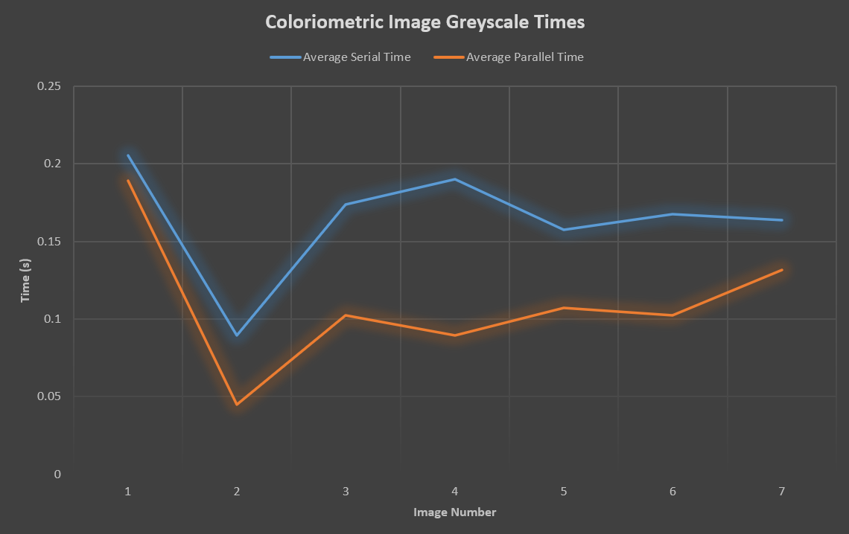

**There was a speedup using the GPU to parallelize this problem, yes. The GPU is suited to this problem both because we have a large number of pixels for each image that can be calculated in parallel (SIMD), and because the GPU has hardware that is optimized for floating point operations. Additionally, the GPU makes use of high memory bandwidth and coalesced memory access (optimization for accessing adjacent memory locations). Images are small enough to load into memory for both problems, but it’s far faster on the GPU as the number of pixels increases. If I had thought to process all of the test images at once, instead of in series, the difference would have been more pronounced.**

**ORIGINAL IMAGES:**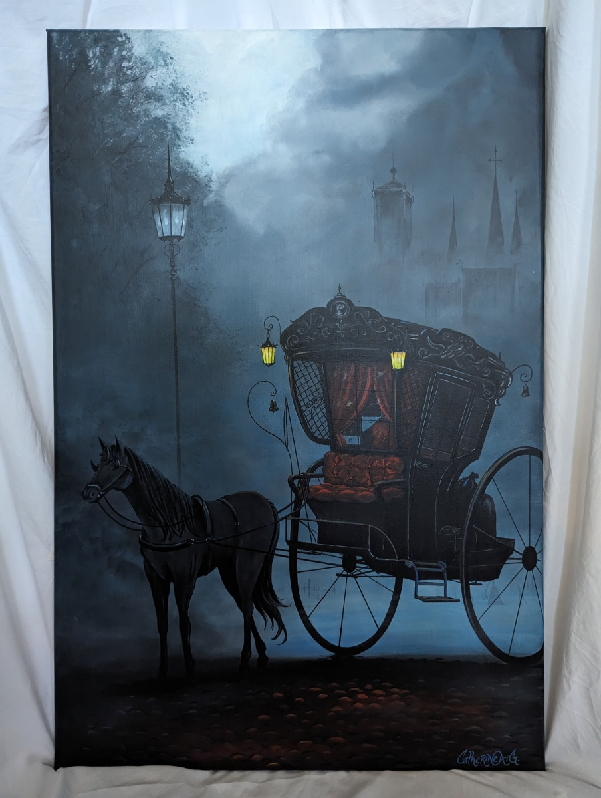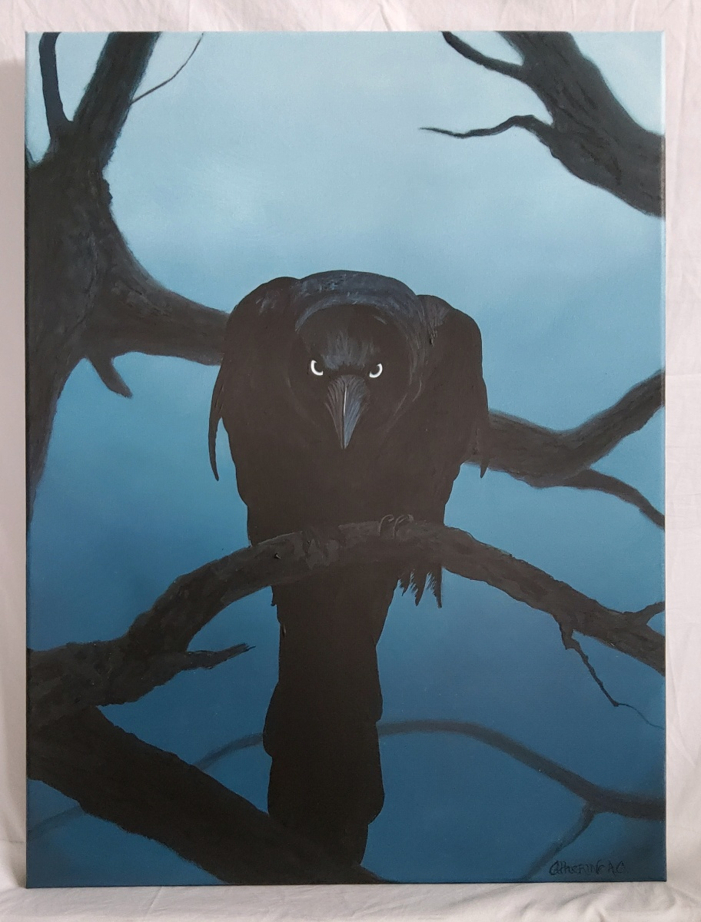

**OUTPUT IMAGES:**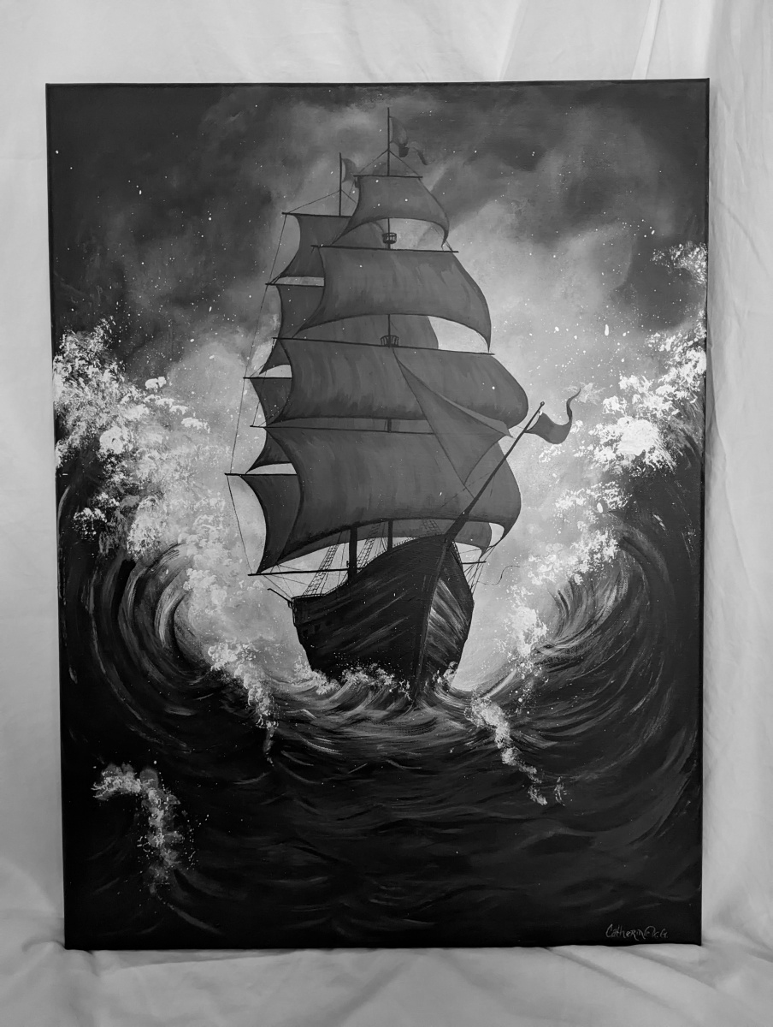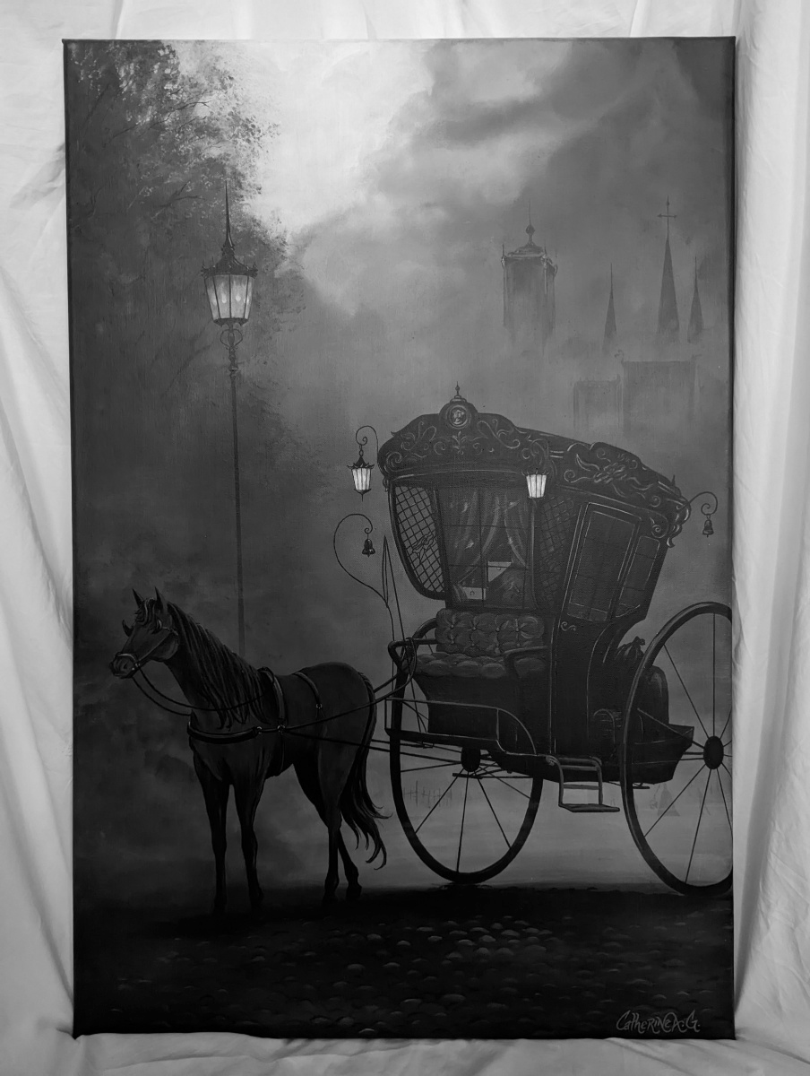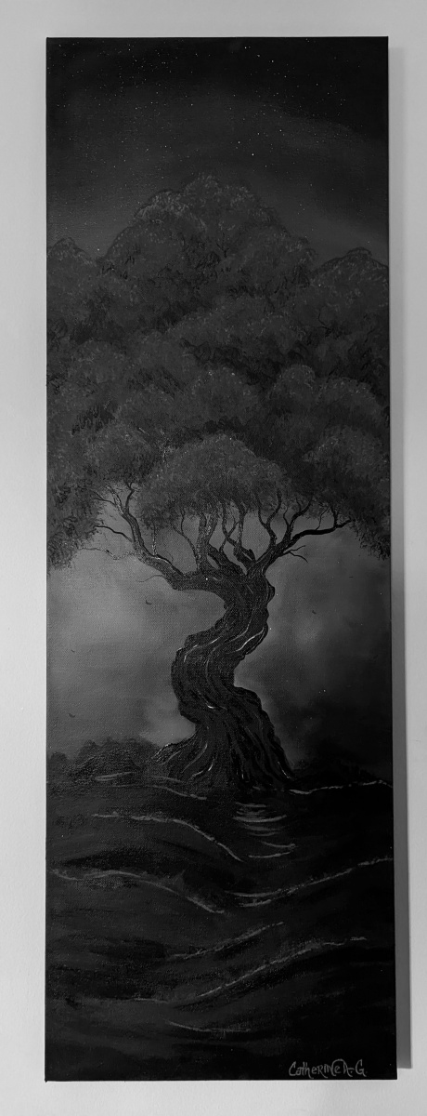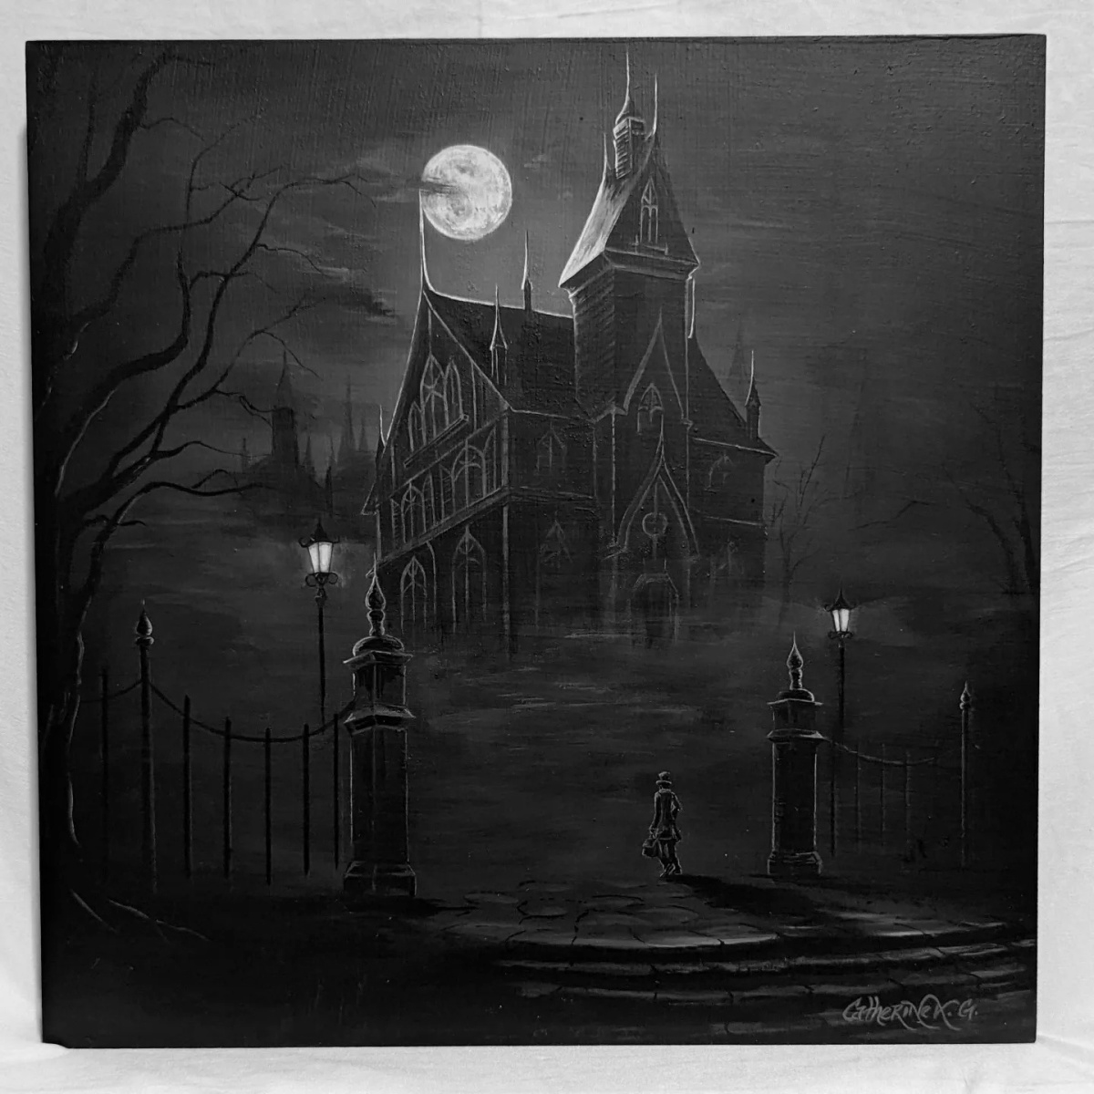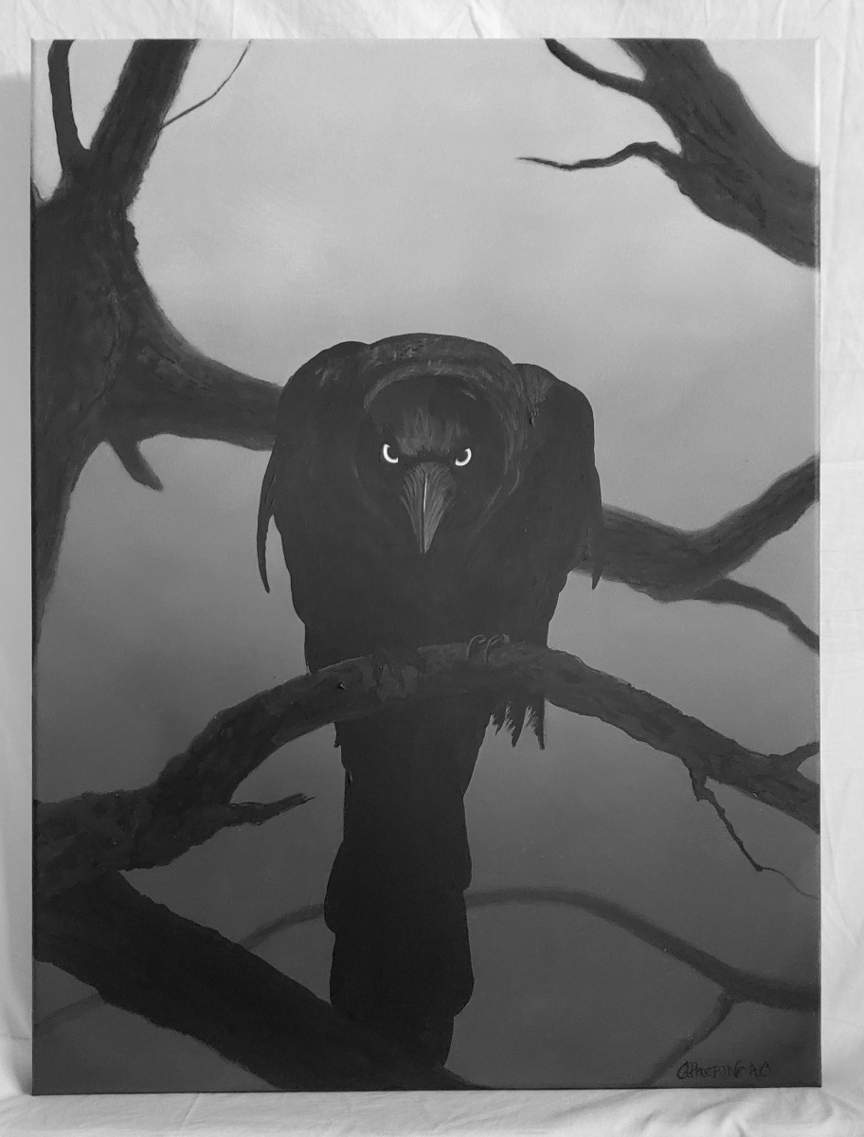

*/\*\**

*\* Author: Jason Gardner*

*\* Date: 11/6/2024*

*\* Class: COP6616 Parallel Computing*

*\* Instructor: Scott Piersall*

*\* Assignment: Homework 3*

*\* Filename: q3.cu*

*\* Description: This program converts a color image to grayscale using the Colorimetric method. It compares the*

*\* performance of a serial CPU-based implementation to a parallel CUDA-based implementation. The program reads*

*\* PNG images from the "in" directory and writes the grayscale images to the "out" directory. The program outputs*

*\* the average time taken for the serial and parallel implementations, the theoretical speedup using Amdahl's law,*

*\* the actual speedup, and the speedup efficiency.*

*\**

*\* INPUT IMAGES ARE OWNED BY CATHERINE ANDERSON OF THE PAINTED ME, LLC AND ARE USED FOR EDUCATIONAL PURPOSES ONLY*

*\* SHE IS MY PARTNER AND I HAVE PERMISSION TO USE THEM (I AM ALSO A PART OWNER OF THE PAINTED ME, LLC)*

*\* IMAGE* ***SOURCE:*** *https://www.thepaintedme.com/*

*\*/*

*/\*\**

*\* (10 points) You are working on team that is building an edge detection module. The first step in edge detection*

*\* is to remove color information and work directly in black-and-white. You do not need to do edge detection, just*

*\* the first step: removing the color information from images. So, please write a CUDA program to convert a color*

*\* image to grayscale using the Colorimetric method. I suggest that you use PNG or BMP images as input.  I want*

*\* to see the original images that you tested with and the output/resulting image. You may do this assignment in*

*\* C or Python, and are free to create a Jupyter notebook. If you do a Jupyter notebook, please include the notebook*

*\* in your assignment report. How does using a GPU for this vs. a serial CPU-based implementation perform? Is there*

*\* a speedup?  How (be specific) is the GPU architecture well-suited to this task?*

*\*/*

*// nvcc -lm -lpng q3.cu -o q3*

*// OR*

*// nvcc -lm q3.cu -o q3 -L$HOME/libpng/lib -I$HOME/libpng/include -lpng*

*// ./q3*

#include <stdio.h>

#include <stdlib.h>

#include <cuda.h>

#include <png.h>

#include <fcntl.h>

#include <unistd.h>

#include <time.h>

#include <string.h>

*// Interestingly, _Bool does not work in nvcc*

#include <stdbool.h>

#include <math.h>

#define PARALLELIZABLE_FRACTION 0.40

#define BLOCK_SIZE 1024

#define NUM_IMAGES 7

#define INPUT_LOCATION "./in/"

#define OUTPUT_LOCATION "./out/"

#define R 0.2126

#define G 0.7152

#define B 0.0722

#define FILENAME_SIZE 256

*/** Struct to store start and stop times */*

typedef **struct** {

**struct** timespec start;

**struct** timespec stop;

} Stopwatch;

*/** Calculate time in seconds*

*\** **@param** *timer: The stopwatch struct*

*\** **@return***: The time in seconds*

*\*/*

**double** calculate_time(Stopwatch timer) {

    return (timer.stop.tv_sec - timer.start.tv_sec) + (timer.stop.tv_nsec - timer.start.tv_nsec) / 1e9;

}

*/** Calculate the theoretical speedup using Amdahl's law */*

**double** amdahl_speedup(**int** p) {

    return 1.0 / ((1.0 - PARALLELIZABLE_FRACTION) + (PARALLELIZABLE_FRACTION / p));

}

*// Convert PNG image to greyscale and save the output (Serial version)*

**void** convertPNGToGreyScaleSerial(**char\*** filename, **char\*** output_filename) {

*// Open the input file*

    FILE* file = fopen(filename, "rb");

    if (!file) {

        fprintf(stderr, "Error opening file %s\n", filename);

        exit(EXIT_FAILURE);

    }

*// Create PNG read struct*

*// png_create_read_struct initializes the PNG structure used for reading data.*

    png_structp png = png_create_read_struct(PNG_LIBPNG_VER_STRING, NULL, NULL, NULL);

    if (!png) {

        fprintf(stderr, "Error creating read struct\n");

        exit(EXIT_FAILURE);

    }

*// Create PNG info struct*

*// png_create_info_struct creates a PNG info structure that stores image information.*

    png_infop info = png_create_info_struct(png);

    if (!info) {

        fprintf(stderr, "Error creating info struct\n");

        exit(EXIT_FAILURE);

    }

*// Set up error handling using setjmp/longjmp mechanism*

*// If any error occurs within libpng, control will jump to this point using longjmp.*

    if (setjmp(png_jmpbuf(png))) {

        fprintf(stderr, "Error during init_io\n");

        exit(EXIT_FAILURE);

    }

*// Initialize PNG IO*

*// png_init_io sets the input file stream for reading PNG data.*

    png_init_io(png, file);

    png_read_info(png, info);

*// Get image information (width, height, color type, bit depth)*

**int** width = png_get_image_width(png, info);

**int** height = png_get_image_height(png, info);

    png_byte color_type = png_get_color_type(png, info);

    png_byte bit_depth = png_get_bit_depth(png, info);

*// Transformations to ensure correct format for processing*

    if (bit_depth == 16) png_set_strip_16(png); *// Strip 16-bit depth to 8-bit*

    if (color_type == PNG_COLOR_TYPE_PALETTE) png_set_palette_to_rgb(png); *// Convert palette images to RGB*

    if (color_type == PNG_COLOR_TYPE_GRAY && bit_depth < 8) png_set_expand_gray_1_2_4_to_8(png); *// Expand grayscale images to 8-bit*

    if (png_get_valid(png, info, PNG_INFO_tRNS)) png_set_tRNS_to_alpha(png); *// Convert transparency to alpha channel*

*// Update the info struct after applying transformations*

    png_read_update_info(png, info);

*// Allocate memory for row pointers (each row of the image)*

*// png_get_rowbytes returns the number of bytes required to hold one row of image data.*

    png_bytep* row_pointers = (png_bytep*)malloc(sizeof(png_bytep) * height);

    for (**int** y = 0; y < height; y++) {

        row_pointers[y] = (png_byte*)malloc(png_get_rowbytes(png, info));

    }

*// Read the image data into row pointers*

*// png_read_image reads the entire image into memory (row_pointers).*

    png_read_image(png, row_pointers);

    fclose(file);

*// Manually convert RGB to grayscale using the given formula*

    for (**int** y = 0; y < height; y++) {

        png_bytep row = row_pointers[y];

        for (**int** x = 0; x < width; x++) {

**int** r = row[x * 3];

**int** g = row[x * 3 + 1];

**int** b = row[x * 3 + 2];

**unsigned** **char** gray = (**unsigned** **char**)(R * r + G * g + B * b);

            row[x * 3] = gray;

            row[x * 3 + 1] = gray;

            row[x * 3 + 2] = gray;

        }

    }

*// Write the greyscale image to the output file*

    FILE* output_file = fopen(output_filename, "wb");

    if (!output_file) {

        fprintf(stderr, "Error opening output file %s\n", output_filename);

        exit(EXIT_FAILURE);

    }

*// Create PNG write struct*

*// png_create_write_struct initializes the PNG structure used for writing data.*

    png_structp png_out = png_create_write_struct(PNG_LIBPNG_VER_STRING, NULL, NULL, NULL);

    if (!png_out) {

        fprintf(stderr, "Error creating write struct\n");

        exit(EXIT_FAILURE);

    }

*// Create PNG info struct for output*

*// png_create_info_struct creates a PNG info structure for writing image information.*

    png_infop info_out = png_create_info_struct(png_out);

    if (!info_out) {

        fprintf(stderr, "Error creating info struct\n");

        exit(EXIT_FAILURE);

    }

*// Set up error handling for writing using setjmp/longjmp*

    if (setjmp(png_jmpbuf(png_out))) {

        fprintf(stderr, "Error during writing header\n");

        exit(EXIT_FAILURE);

    }

*// Initialize PNG IO for output file*

*// png_init_io sets the output file stream for writing PNG data.*

    png_init_io(png_out, output_file);

    png_set_IHDR(

        png_out,

        info_out,

        width, height,

        8, *// Bit depth*

        PNG_COLOR_TYPE_RGB, *// Color type*

        PNG_INTERLACE_NONE,

        PNG_COMPRESSION_TYPE_DEFAULT,

        PNG_FILTER_TYPE_DEFAULT

    );

    png_write_info(png_out, info_out);

*// Write the image data row by row*

    if (setjmp(png_jmpbuf(png_out))) {

        fprintf(stderr, "Error during writing bytes\n");

        exit(EXIT_FAILURE);

    }

    for (**int** y = 0; y < height; y++) {

        png_bytep row = row_pointers[y];

        png_write_row(png_out, row);

    }

*// Finalize writing the PNG file*

    if (setjmp(png_jmpbuf(png_out))) {

        fprintf(stderr, "Error during end of write\n");

        exit(EXIT_FAILURE);

    }

    png_write_end(png_out, NULL);

*// Cleanup allocated memory*

    for (**int** y = 0; y < height; y++) {

        free(row_pointers[y]);

    }

    free(row_pointers);

    fclose(output_file);

}

*// Convert PNG image to greyscale and save the output (CUDA version)*

**__global__** **void** greyscale_kernel(**unsigned** **char\*** d_input, **unsigned** **char\*** d_output, **int** width, **int** height) {

**int** idx = **blockIdx**.x * **blockDim**.x + **threadIdx**.x;

    if (idx < width * height) {

**int** pixel_idx = idx * 3;

**int** r = d_input[pixel_idx];

**int** g = d_input[pixel_idx + 1];

**int** b = d_input[pixel_idx + 2];

        d_output[idx] = (**unsigned** **char**)(R * r + G * g + B * b);

    }

}

**void** convertPNGToGreyScaleCUDA(**char\*** filename, **char\*** output_filename) {

*// Open the input file*

    FILE* file = fopen(filename, "rb");

    if (!file) {

        fprintf(stderr, "Error opening file %s\n", filename);

        exit(EXIT_FAILURE);

    }

*// Create PNG read struct*

*// png_create_read_struct initializes the PNG structure used for reading data.*

    png_structp png = png_create_read_struct(PNG_LIBPNG_VER_STRING, NULL, NULL, NULL);

    if (!png) {

        fprintf(stderr, "Error creating read struct\n");

        exit(EXIT_FAILURE);

    }

*// Create PNG info struct*

*// png_create_info_struct creates a PNG info structure that stores image information.*

    png_infop info = png_create_info_struct(png);

    if (!info) {

        fprintf(stderr, "Error creating info struct\n");

        exit(EXIT_FAILURE);

    }

*// Set up error handling using setjmp/longjmp mechanism*

    if (setjmp(png_jmpbuf(png))) {

        fprintf(stderr, "Error during init_io\n");

        exit(EXIT_FAILURE);

    }

*// Initialize PNG IO*

*// png_init_io sets the input file stream for reading PNG data.*

    png_init_io(png, file);

    png_read_info(png, info);

*// Get image information (width, height, color type, bit depth)*

**int** width = png_get_image_width(png, info);

**int** height = png_get_image_height(png, info);

    png_byte color_type = png_get_color_type(png, info);

    png_byte bit_depth = png_get_bit_depth(png, info);

*// Transformations to ensure correct format for processing*

    if (bit_depth == 16) png_set_strip_16(png); *// Strip 16-bit depth to 8-bit*

    if (color_type == PNG_COLOR_TYPE_PALETTE) png_set_palette_to_rgb(png); *// Convert palette images to RGB*

    if (color_type == PNG_COLOR_TYPE_GRAY && bit_depth < 8) png_set_expand_gray_1_2_4_to_8(png); *// Expand grayscale images to 8-bit*

    if (png_get_valid(png, info, PNG_INFO_tRNS)) png_set_tRNS_to_alpha(png); *// Convert transparency to alpha channel*

*// Update the info struct after applying transformations*

    png_read_update_info(png, info);

*// Allocate memory for row pointers (each row of the image)*

*// png_get_rowbytes returns the number of bytes required to hold one row of image data.*

    png_bytep* row_pointers = (png_bytep*)malloc(sizeof(png_bytep) * height);

    for (**int** y = 0; y < height; y++) {

        row_pointers[y] = (png_byte*)malloc(png_get_rowbytes(png, info));

    }

*// Read the image data into row pointers*

*// png_read_image reads the entire image into memory (row_pointers).*

    png_read_image(png, row_pointers);

    fclose(file);

*// Copy image data to linear buffer (h_input)*

**unsigned** **char**\* h_input = (**unsigned** **char**\*)malloc(3 * width * height);

**unsigned** **char**\* h_output = (**unsigned** **char**\*)malloc(width * height);

    for (**int** y = 0; y < height; y++) {

        memcpy(h_input + y * width * 3, row_pointers[y], png_get_rowbytes(png, info));

    }

*// Allocate device memory and copy data to GPU*

**unsigned** **char** *d_input, *d_output;

    cudaMalloc(&d_input, 3 * width * height);

    cudaMalloc(&d_output, width * height);

    cudaMemcpy(d_input, h_input, 3 * width * height, cudaMemcpyHostToDevice);

*// Launch kernel to convert to greyscale*

**int** num_threads = BLOCK_SIZE;

**int** num_blocks = (width * height + num_threads - 1) / num_threads;

    greyscale_kernel<<<num_blocks, num_threads>>>(d_input, d_output, width, height);

*// Copy result back to host*

    cudaMemcpy(h_output, d_output, width * height, cudaMemcpyDeviceToHost);

*// Write the greyscale image to the output file*

    FILE* output_file = fopen(output_filename, "wb");

    if (!output_file) {

        fprintf(stderr, "Error opening output file %s\n", output_filename);

        exit(EXIT_FAILURE);

    }

*// Create PNG write struct*

*// png_create_write_struct initializes the PNG structure used for writing data.*

    png_structp png_out = png_create_write_struct(PNG_LIBPNG_VER_STRING, NULL, NULL, NULL);

    if (!png_out) {

        fprintf(stderr, "Error creating write struct\n");

        exit(EXIT_FAILURE);

    }

*// Create PNG info struct for output*

*// png_create_info_struct creates a PNG info structure for writing image information.*

    png_infop info_out = png_create_info_struct(png_out);

    if (!info_out) {

        fprintf(stderr, "Error creating info struct\n");

        exit(EXIT_FAILURE);

    }

*// Set up error handling for writing using setjmp/longjmp*

    if (setjmp(png_jmpbuf(png_out))) {

        fprintf(stderr, "Error during writing header\n");

        exit(EXIT_FAILURE);

    }

*// Initialize PNG IO for output file*

*// png_init_io sets the output file stream for writing PNG data.*

    png_init_io(png_out, output_file);

    png_set_IHDR(

        png_out,

        info_out,

        width, height,

        8, *// Bit depth*

        PNG_COLOR_TYPE_GRAY, *// Color type*

        PNG_INTERLACE_NONE,

        PNG_COMPRESSION_TYPE_DEFAULT,

        PNG_FILTER_TYPE_DEFAULT

    );

    png_write_info(png_out, info_out);

*// Write the image data row by row*

    if (setjmp(png_jmpbuf(png_out))) {

        fprintf(stderr, "Error during writing bytes\n");

        exit(EXIT_FAILURE);

    }

    for (**int** y = 0; y < height; y++) {

        png_bytep row = (png_bytep)malloc(width * sizeof(png_byte));

        for (**int** x = 0; x < width; x++) {

            row[x] = h_output[y * width + x];

        }

        png_write_row(png_out, row);

        free(row);

    }

*// Finalize writing the PNG file*

    if (setjmp(png_jmpbuf(png_out))) {

        fprintf(stderr, "Error during end of write\n");

        exit(EXIT_FAILURE);

    }

    png_write_end(png_out, NULL);

*// Cleanup allocated memory*

    for (**int** y = 0; y < height; y++) {

        free(row_pointers[y]);

    }

    free(row_pointers);

    free(h_input);

    free(h_output);

    cudaFree(d_input);

    cudaFree(d_output);

    fclose(output_file);

}

*/\*\**

*\* Main function*

*\** **@param** *argc: Number of arguments*

*\** **@param** *argv: Array of arguments*

*\** **@return***: 0 if successful*

*\*/*

**int** main(**int** argc, **char\*\*** argv) {

**char** input_filename[FILENAME_SIZE];

**char** output_filename_s[FILENAME_SIZE];

**char** output_filename_c[FILENAME_SIZE];

    for (**int** image_num = 1; image_num < NUM_IMAGES + 1; image_num++) {

*// Create output filenames*

        sprintf(input_filename, "%s%d.png", INPUT_LOCATION, image_num);

        sprintf(output_filename_s, "%simage_%d_s.png", OUTPUT_LOCATION, image_num);

        sprintf(output_filename_c, "%simage_%d_c.png", OUTPUT_LOCATION, image_num);

        Stopwatch parallel_timer, serial_timer;

*// Start serial timing*

        clock_gettime(CLOCK_MONOTONIC, &serial_timer.start);

        convertPNGToGreyScaleSerial(input_filename, output_filename_s);

        clock_gettime(CLOCK_MONOTONIC, &serial_timer.stop);

**double** total_serial_time = calculate_time(serial_timer);

*// Start parallel timing*

        clock_gettime(CLOCK_MONOTONIC, &parallel_timer.start);

        convertPNGToGreyScaleCUDA(input_filename, output_filename_c);

        clock_gettime(CLOCK_MONOTONIC, &parallel_timer.stop);

**double** total_parallel_time = calculate_time(parallel_timer);

*// Output results and speedup calculations*

**double** actual_speedup = total_serial_time / total_parallel_time;

**double** theoretical_speedup = amdahl_speedup(BLOCK_SIZE);

**double** speedup_ratio = (actual_speedup / theoretical_speedup) * 100;

        printf("Image %d:\n", image_num);

        printf("Average Serial Time:\t\t\t%lfs\n", total_serial_time);

        printf("Average Parallel Time:\t\t\t%lfs\n", total_parallel_time);

        printf("Theoretical Speedup [Amdahl's Law]:\t%lf\n", theoretical_speedup);

        printf("Actual Speedup:\t\t\t%lf\n", actual_speedup);

        printf("Speedup Efficiency:\t\t\t%lf%%\n\n", speedup_ratio);

    }

    return 0;

}

1. **(11 points)** Write a matrix multiplication program that uses GPU/CUDA. Your matrices should consist of floating-point values (NOT INTEGERS). You may do this assignment in C, Python, and are free to create a Jupyter notebook. If you do a Jupyter notebook, please include the notebook in your assignment report. You should run MANY experiments with varying sized matrices. What is the speedup? Is the speedup affected by matrix size? Explain (diagrams are useful here) how the GPU implementation of this code differs from a serial (CPU-based) implementation.

**Full testing of this code was ultimately limited by having to run the serial code. I also tested with integers, because I had read a study where somebody used integers and “it’s much easier math” for AI. But, at the limits of what I could test on the GPU at the school, I didn’t see an improvement with floating point numbers. Given I wrote about it for question 3, I’m a bit confused. It’s supposed to be a benefit, but the GPU handled integers like a champ. The speedups are the right two fields of the table on page 58. Once the matrix size becomes large, the speedup starts increasing, by a substantial amount.**

|  |  |  |
| --- | --- | --- |
|  | **CPU** | **GPU** |
| **Parallelism** | **Sequential, one matrix element at a time** | **Thousands of parallel threads calculating matrix elements concurrently** |
| **Memory Access Patterns** | **Main memory or cache** | **Hierarchal memory model, shared memory reducing global accesses** |
| **Computation Distribution** | **Single thread handles all computation, limited by clock speed/cores.** | **Distributed across many threads. Exploits data-level parallelism inherent in matrix multiplication.** |
| **Synchronization** | **N/A** | **Utilizes __syncthreads() to synchronize threads within a block. Ensures all threads have loaded data into shared memory.** |
| **Code Structure** | **void matrixMultiplySerial(double* A, double* B, double* C, int m, int n, int k) {**  **for (int i = 0; i < m; i++) {**  **for (int j = 0; j < k; j++) {**  **double sum = 0;**  **for (int l = 0; l < n; l++) {**  **sum += A[i * n + l] * B[l * k + j];**  **}**  **C[i * k + j] = sum;**  **}**  **}**  **}** | **__global__ void matrixMultiplyKernelShared(double* A, double* B, double* C, int m, int n, int k) {**  **__shared__ double As[BLOCK_SIZE][BLOCK_SIZE];**  **__shared__ double Bs[BLOCK_SIZE][BLOCK_SIZE];**  **int row = blockIdx.y * blockDim.y + threadIdx.y;**  **int col = blockIdx.x * blockDim.x + threadIdx.x;**  **double value = 0.0;**  **for (int t = 0; t < (n + BLOCK_SIZE - 1) / BLOCK_SIZE; t++) {**  ***// Data -> Shared memory***  ***// Synchronize threads***  ***// Compute partial sums***  **}**  **if (row < m && col < k) {**  **C[row * k + col] = value;**  **}**  **}** |
| **Performance** | **Limited by CPU speed and memory bandwidth** | **Benefits from massive parallelism. Scales well into larger matrices due to parallel computation.** |

|  |  |  |  |  |  |  |  |  |  |  |
| --- | --- | --- | --- | --- | --- | --- | --- | --- | --- | --- |
| **m** | **n** | **k** | **Integer** | | **Double** | | **Δts (s)** | **Δtp (s)** | **Si** | **Sd** |
| **Serial Time (s)** | **Parallel Time (s)** | **Serial Time (s)** | **Parallel Time (s)** |
| **10** | **10** | **10** | **0.000002** | **0.000140** | **0.000002** | **0.000570** | **0.000000** | **-0.000429** | **0.01428571** | **0.00350877** |
| **20** | **20** | **20** | **0.000014** | **0.000129** | **0.000015** | **0.000559** | **-0.000001** | **-0.000430** | **0.10852713** | **0.02683363** |
| **30** | **30** | **30** | **0.000045** | **0.000100** | **0.000050** | **0.000524** | **-0.000005** | **-0.000425** | **0.45** | **0.09541985** |
| **40** | **40** | **40** | **0.000115** | **0.000099** | **0.000124** | **0.000535** | **-0.000010** | **-0.000436** | **1.16161616** | **0.2317757** |
| **50** | **50** | **50** | **0.000207** | **0.000101** | **0.000229** | **0.000530** | **-0.000022** | **-0.000428** | **2.04950495** | **0.43207547** |
| **60** | **60** | **60** | **0.000365** | **0.000107** | **0.000397** | **0.000533** | **-0.000032** | **-0.000426** | **3.41121495** | **0.74484053** |
| **70** | **70** | **70** | **0.000567** | **0.000110** | **0.000634** | **0.000554** | **-0.000067** | **-0.000444** | **5.15454545** | **1.14440433** |
| **80** | **80** | **80** | **0.000889** | **0.000112** | **0.000966** | **0.000553** | **-0.000077** | **-0.000441** | **7.9375** | **1.74683544** |
| **90** | **90** | **90** | **0.001210** | **0.000125** | **0.001342** | **0.000574** | **-0.000131** | **-0.000125** | **9.68** | **2.33797909** |
| **100** | **100** | **100** | **0.001727** | **0.000129** | **0.001879** | **0.000558** | **-0.000152** | **-0.000429** | **13.3875969** | **3.36738351** |
| **100** | **100** | **1000** | **0.019716** | **0.000308** | **0.021104** | **0.001074** | **-0.001388** | **-0.000766** | **64.012987** | **19.6499069** |
| **100** | **100** | **5000** | **0.099439** | **0.001489** | **0.105567** | **0.002920** | **-0.006127** | **-0.001431** | **66.7824043** | **36.1530822** |
| **1000** | **1000** | **5000** | **13.646605** | **0.046152** | **19.005602** | **0.137432** | **-5.358997** | **-0.091280** | **295.688269** | **138.290951** |
| **1000** | **1000** | **10000** | **29.542459** | **0.085631** | **35.720104** | **0.185100** | **-6.177645** | **-0.099470** | **344.997244** | **192.977331** |

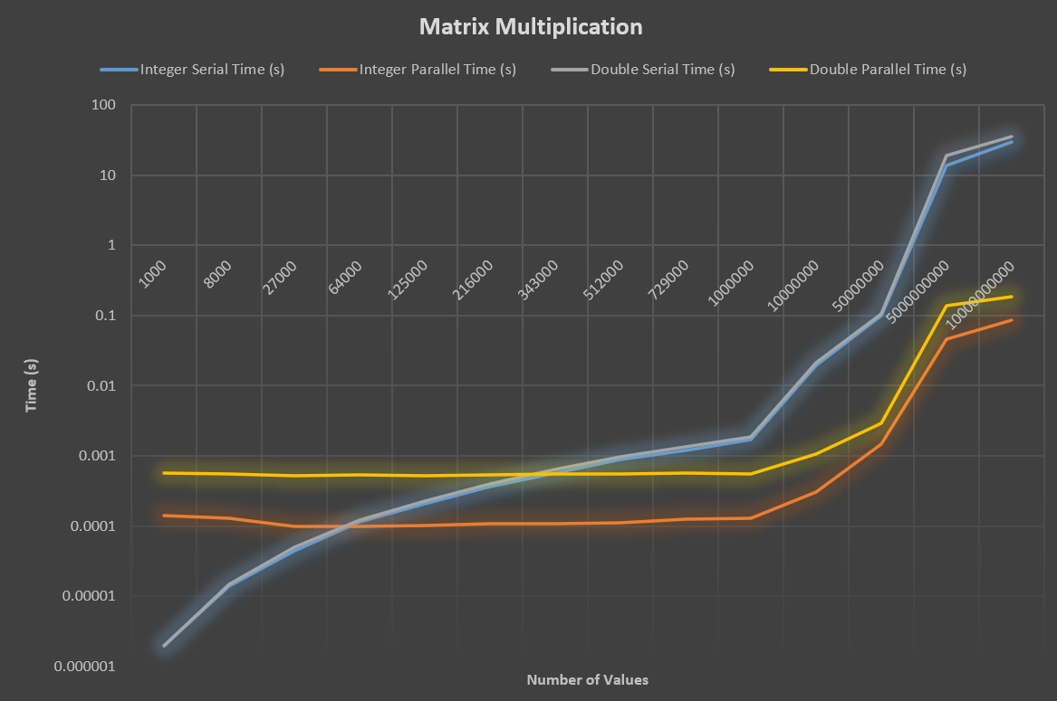

*/\*\**

*\* Author: Jason Gardner*

*\* Date: 11/6/2024*

*\* Class: COP6616 Parallel Computing*

*\* Instructor: Scott Piersall*

*\* Assignment: Homework 3*

*\* Filename: q4.cu*

*\* Description: This program computes the multiplication of two matrices using CUDA. The matrices are filled with random*

*\* values and the results are compared to a serial implementation. The program calculates the average time for both the*

*\* serial and parallel implementations, as well as the theoretical and actual speedup. The program also outputs the*

*\* difference in average serial time, average parallel time, theoretical speedup, actual speedup, and speedup efficiency*

*\* between the double and integer implementations.*

*\*/*

*/\*\**

*\* (11 points) Write a matrix multiplication program that uses GPU/CUDA. Your matrices should consist*

*\* of floating-point values (NOT INTEGERS). You may do this assignment in C, Python, and are free to create*

*\* a Jupyter notebook. If you do a Jupyter notebook, please include the notebook in your assignment report.*

*\* You should run MANY experiments with varying sized matrices. What is the speedup? Is the speedup affected*

*\* by matrix size? Explain (diagrams are useful here) how the GPU implementation of this code differs from*

*\* a serial (CPU-based) implementation.*

*\*/*

*// nvcc -lm q4.cu -o q4*

*// ./q4 1000000 1000000 100*

#include <stdio.h>

#include <stdlib.h>

#include <cuda.h>

#include <fcntl.h>

#include <unistd.h>

#include <time.h>

#include <string.h>

#include <stdbool.h>

#include <math.h>

#define MIN 0

#define MAX 99

#define TOLERANCE 0.000001

#define PARALLELIZABLE_FRACTION_DOUBLE 0.40

#define PARALLELIZABLE_FRACTION_INTEGER 0.99

#define BLOCK_SIZE 16

#define MAX_ELEMENTS 1000000000 *// Threshold for warning about potential segmentation faults*

*/** Struct to store start and stop times */*

typedef **struct** {

**struct** timespec start;

**struct** timespec stop;

} Stopwatch;

*/** Seed the random number generator with entropy from /dev/urandom */*

**void** seed_random() {

**int** fd = open("/dev/urandom", O_RDONLY);

**unsigned** **int** seed;

    read(fd, &seed, sizeof(seed));

    close(fd);

    srandom(seed);

}

*/** Calculate time in seconds*

*\** **@param** *timer: The stopwatch struct*

*\** **@return***: The time in seconds*

*\*/*

**double** calculate_time(Stopwatch timer) {

    return (timer.stop.tv_sec - timer.start.tv_sec) + (timer.stop.tv_nsec - timer.start.tv_nsec) / 1e9;

}

*/** Calculate the theoretical speedup using Amdahl's law */*

**double** amdahl_speedup(**int** p, **double** PARALLELIZABLE_FRACTION) {

    return 1.0 / ((1.0 - PARALLELIZABLE_FRACTION) + (PARALLELIZABLE_FRACTION / p));

}

*/\*\**

*\* Generate a random double value between MIN and MAX*

*\** **@return***: A random double value*

*\*/*

**double** random_double() {

    return MIN + ((**double**)rand() / RAND_MAX) * (MAX - MIN);

}

*/\*\**

*\* Generate a random integer value between MIN and MAX*

*\** **@return***: A random integer value*

*\*/*

**int** random_int() {

    return MIN + rand() % (MAX - MIN + 1);

}

*/** Function to compare two matrices with a tolerance */*

**bool** compare_matrices(**double\*** C_serial, **double\*** C_parallel, **int** m, **int** k) {

    for (**int** i = 0; i < m * k; i++) {

        if (fabs(C_serial[i] - C_parallel[i]) > TOLERANCE) {

            return false;

        }

    }

    return true;

}

*/** Matrix multiplication in serial (double) */*

**void** matrixMultiplySerial(**double\*** A, **double\*** B, **double\*** C, **int** m, **int** n, **int** k) {

    for (**int** i = 0; i < m; i++) {

        for (**int** j = 0; j < k; j++) {

**double** sum = 0;

            for (**int** l = 0; l < n; l++) {

                sum += A[i * n + l] * B[l * k + j];

            }

            C[i * k + j] = sum;

        }

    }

}

*/** Matrix multiplication in serial (int) */*

**void** matrixMultiplySerialInt(**int\*** A, **int\*** B, **int\*** C, **int** m, **int** n, **int** k) {

    for (**int** i = 0; i < m; i++) {

        for (**int** j = 0; j < k; j++) {

**int** sum = 0;

            for (**int** l = 0; l < n; l++) {

                sum += A[i * n + l] * B[l * k + j];

            }

            C[i * k + j] = sum;

        }

    }

}

*/** CUDA kernel for matrix multiplication using shared memory (double) */*

**__global__** **void** matrixMultiplyKernelShared(**double\*** A, **double\*** B, **double\*** C, **int** m, **int** n, **int** k) {

**__shared__** **double** As[BLOCK_SIZE][BLOCK_SIZE];

**__shared__** **double** Bs[BLOCK_SIZE][BLOCK_SIZE];

**int** row = **blockIdx**.y * **blockDim**.y + **threadIdx**.y;

**int** col = **blockIdx**.x * **blockDim**.x + **threadIdx**.x;

**double** value = 0.0;

    for (**int** t = 0; t < (n + BLOCK_SIZE - 1) / BLOCK_SIZE; t++) {

        if (row < m && (t * BLOCK_SIZE + **threadIdx**.x) < n) {

            As[threadIdx.y][threadIdx.x] = A[row * n + t * BLOCK_SIZE + **threadIdx**.x];

        } else {

            As[threadIdx.y][threadIdx.x] = 0.0;

        }

        if ((t * BLOCK_SIZE + **threadIdx**.y) < n && col < k) {

            Bs[threadIdx.y][threadIdx.x] = B[(t * BLOCK_SIZE + **threadIdx**.y) * k + col];

        } else {

            Bs[threadIdx.y][threadIdx.x] = 0.0;

        }

        __syncthreads();

        for (**int** i = 0; i < BLOCK_SIZE; i++) {

            value += As[threadIdx.y][i] * Bs[i][threadIdx.x];

        }

        __syncthreads();

    }

    if (row < m && col < k) {

        C[row * k + col] = value;

    }

}

*/** CUDA kernel for matrix multiplication (int) */*

**__global__** **void** matrixMultiplyKernelInt(**int\*** A, **int\*** B, **int\*** C, **int** m, **int** n, **int** k) {

**int** row = **blockIdx**.y * **blockDim**.y + **threadIdx**.y;

**int** col = **blockIdx**.x * **blockDim**.x + **threadIdx**.x;

    if (row < m && col < k) {

**int** value = 0;

        for (**int** i = 0; i < n; i++) {

            value += A[row * n + i] * B[i * k + col];

        }

        C[row * k + col] = value;

    }

}

*/** Host function for matrix multiplication using CUDA (double) */*

**void** matrixMultiplyCUDA(**double\*** A, **double\*** B, **double\*** C, **int** m, **int** n, **int** k) {

**double** *d_A, *d_B, *d_C;

*// Allocate device memory*

    cudaError_t err;

    err = cudaMalloc((**void**\*\*)&d_A, m * n * sizeof(**double**));

    if (err != cudaSuccess) {

        fprintf(stderr, "CUDA malloc failed for A: %s\n", cudaGetErrorString(err));

        exit(EXIT_FAILURE);

    }

    err = cudaMalloc((**void**\*\*)&d_B, n * k * sizeof(**double**));

    if (err != cudaSuccess) {

        fprintf(stderr, "CUDA malloc failed for B: %s\n", cudaGetErrorString(err));

        exit(EXIT_FAILURE);

    }

    err = cudaMalloc((**void**\*\*)&d_C, m * k * sizeof(**double**));

    if (err != cudaSuccess) {

        fprintf(stderr, "CUDA malloc failed for C: %s\n", cudaGetErrorString(err));

        exit(EXIT_FAILURE);

    }

*// Copy matrices from host to device*

    cudaMemcpy(d_A, A, m * n * sizeof(**double**), cudaMemcpyHostToDevice);

    cudaMemcpy(d_B, B, n * k * sizeof(**double**), cudaMemcpyHostToDevice);

*// Define block and grid sizes*

**dim3** blockSize(BLOCK_SIZE, BLOCK_SIZE);

**dim3** gridSize((k + blockSize.x - 1) / blockSize.x, (m + blockSize.y - 1) / blockSize.y);

*// Launch the kernel*

    matrixMultiplyKernelShared<<<gridSize, blockSize>>>(d_A, d_B, d_C, m, n, k);

    cudaDeviceSynchronize();

*// Copy result back to host*

    cudaMemcpy(C, d_C, m * k * sizeof(**double**), cudaMemcpyDeviceToHost);

*// Free device memory*

    cudaFree(d_A);

    cudaFree(d_B);

    cudaFree(d_C);

}

*/** Host function for matrix multiplication using CUDA (int) */*

**void** matrixMultiplyCUDAInt(**int\*** A, **int\*** B, **int\*** C, **int** m, **int** n, **int** k) {

**int** *d_A, *d_B, *d_C;

*// Allocate device memory*

    cudaError_t err;

    err = cudaMalloc((**void**\*\*)&d_A, m * n * sizeof(**int**));

    if (err != cudaSuccess) {

        fprintf(stderr, "CUDA malloc failed for A: %s\n", cudaGetErrorString(err));

        exit(EXIT_FAILURE);

    }

    err = cudaMalloc((**void**\*\*)&d_B, n * k * sizeof(**int**));

    if (err != cudaSuccess) {

        fprintf(stderr, "CUDA malloc failed for B: %s\n", cudaGetErrorString(err));

        exit(EXIT_FAILURE);

    }

    err = cudaMalloc((**void**\*\*)&d_C, m * k * sizeof(**int**));

    if (err != cudaSuccess) {

        fprintf(stderr, "CUDA malloc failed for C: %s\n", cudaGetErrorString(err));

        exit(EXIT_FAILURE);

    }

*// Copy matrices from host to device*

    cudaMemcpy(d_A, A, m * n * sizeof(**int**), cudaMemcpyHostToDevice);

    cudaMemcpy(d_B, B, n * k * sizeof(**int**), cudaMemcpyHostToDevice);

*// Define block and grid sizes*

**dim3** blockSize(BLOCK_SIZE, BLOCK_SIZE);

**dim3** gridSize((k + blockSize.x - 1) / blockSize.x, (m + blockSize.y - 1) / blockSize.y);

*// Launch the kernel*

    matrixMultiplyKernelInt<<<gridSize, blockSize>>>(d_A, d_B, d_C, m, n, k);

    cudaDeviceSynchronize();

*// Copy result back to host*

    cudaMemcpy(C, d_C, m * k * sizeof(**int**), cudaMemcpyDeviceToHost);

*// Free device memory*

    cudaFree(d_A);

    cudaFree(d_B);

    cudaFree(d_C);

}

*/** Main function */*

**int** main(**int** argc, **char\*\*** argv) {

*// Command line argument variables*

**unsigned** **int** m = 512, n = 512, k = 512, num_runs = 10;

*// Parse command line arguments or use default values*

    if (argc > 1) {

        if (sscanf(argv[1], "%u", &m) != 1) {

            printf("Invalid value for m. Using default: m = 512\n");

            m = 512;

        }

    } else {

        printf("Missing value for m. Using default: m = 512\n");

    }

    if (argc > 2) {

        if (sscanf(argv[2], "%u", &n) != 1) {

            printf("Invalid value for n. Using default: n = 512\n");

            n = 512;

        }

    } else {

        printf("Missing value for n. Using default: n = 512\n");

    }

    if (argc > 3) {

        if (sscanf(argv[3], "%u", &k) != 1) {

            printf("Invalid value for k. Using default: k = 512\n");

            k = 512;

        }

    } else {

        printf("Missing value for k. Using default: k = 512\n");

    }

    if (argc > 4) {

        if (sscanf(argv[4], "%u", &num_runs) != 1) {

            printf("Invalid value for num_runs. Using default: num_runs = 10\n");

            num_runs = 10;

        }

    } else {

        printf("Missing value for num_runs. Using default: num_runs = 10\n");

    }

*// Validate command line arguments*

    if (m < 1 || n < 1 || k < 1 || num_runs < 1) {

        fprintf(stderr, "Matrix dimensions and number of runs must be greater than 0!\n");

        exit(EXIT_FAILURE);

    }

*// Check if the total number of elements is too large*

**unsigned** **long** **long** total_elements = (**unsigned** **long** **long**)m * n * k;

    if (total_elements > MAX_ELEMENTS) {

**unsigned** **long** **long** estimated_memory = (**unsigned** **long** **long**)(m * n * sizeof(**double**) + n * k * sizeof(**double**) + m * k * sizeof(**double**));

**double** estimated_memory_mb = estimated_memory / (1024.0 * 1024.0);

**double** estimated_memory_gb = estimated_memory / (1024.0 * 1024.0 * 1024.0);

        fprintf(stderr, "Warning: The total number of elements (%llu) may be too large and could lead to a segmentation fault due to", total_elements);

        fprintf(stderr, "\ninsufficient memory! Estimated memory usage: %.2lf MB (%.2lf GB).\n", estimated_memory_mb, estimated_memory_gb);

    }

*// Allocate memory for matrices (double)*

**double**\* A_d = (**double**\*)malloc(m * n * sizeof(**double**));

**double**\* B_d = (**double**\*)malloc(n * k * sizeof(**double**));

**double**\* C_serial_d = (**double**\*)malloc(m * k * sizeof(**double**));

**double**\* C_parallel_d = (**double**\*)malloc(m * k * sizeof(**double**));

    if (!A_d || !B_d || !C_serial_d || !C_parallel_d) {

        fprintf(stderr, "Matrix memory allocation failed for double matrices!\n");

        exit(EXIT_FAILURE);

    }

*// Allocate memory for matrices (int)*

**int**\* A_i = (**int**\*)malloc(m * n * sizeof(**int**));

**int**\* B_i = (**int**\*)malloc(n * k * sizeof(**int**));

**int**\* C_serial_i = (**int**\*)malloc(m * k * sizeof(**int**));

**int**\* C_parallel_i = (**int**\*)malloc(m * k * sizeof(**int**));

    if (!A_i || !B_i || !C_serial_i || !C_parallel_i) {

        fprintf(stderr, "Matrix memory allocation failed for int matrices!\n");

        exit(EXIT_FAILURE);

    }

*// Fill matrices with random values*

    seed_random();

    for (**int** i = 0; i < m * n; i++) {

        A_d[i] = random_double();

        A_i[i] = random_int();

    }

    for (**int** i = 0; i < n * k; i++) {

        B_d[i] = random_double();

        B_i[i] = random_int();

    }

*// Variables for tracking time*

**double** total_parallel_time_d = 0;

**double** total_serial_time_d = 0;

**double** total_parallel_time_i = 0;

**double** total_serial_time_i = 0;

*// Perform the matrix multiplication for num_runs (double)*

    for (**unsigned** **int** run = 0; run < num_runs; run++) {

        Stopwatch parallel_timer, serial_timer;

*// Start parallel timing (double)*

        clock_gettime(CLOCK_MONOTONIC, &parallel_timer.start);

*// Perform parallel matrix multiplication (double)*

        matrixMultiplyCUDA(A_d, B_d, C_parallel_d, m, n, k);

*// Stop parallel timing (double)*

        clock_gettime(CLOCK_MONOTONIC, &parallel_timer.stop);

        total_parallel_time_d += calculate_time(parallel_timer);

*// Start serial timing (double)*

        clock_gettime(CLOCK_MONOTONIC, &serial_timer.start);

*// Perform serial matrix multiplication (double)*

        matrixMultiplySerial(A_d, B_d, C_serial_d, m, n, k);

        clock_gettime(CLOCK_MONOTONIC, &serial_timer.stop);

        total_serial_time_d += calculate_time(serial_timer);

*// Compare results (double)*

        if (!compare_matrices(C_serial_d, C_parallel_d, m, k)) {

            fprintf(stderr, "Error: Double matrices do not match in run %u!\n", run + 1);

        }

    }

*// Perform the matrix multiplication for num_runs (int)*

    for (**unsigned** **int** run = 0; run < num_runs; run++) {

        Stopwatch parallel_timer, serial_timer;

*// Start parallel timing (int)*

        clock_gettime(CLOCK_MONOTONIC, &parallel_timer.start);

*// Perform parallel matrix multiplication (int)*

        matrixMultiplyCUDAInt(A_i, B_i, C_parallel_i, m, n, k);

*// Stop parallel timing (int)*

        clock_gettime(CLOCK_MONOTONIC, &parallel_timer.stop);

        total_parallel_time_i += calculate_time(parallel_timer);

*// Start serial timing (int)*

        clock_gettime(CLOCK_MONOTONIC, &serial_timer.start);

*// Perform serial matrix multiplication (int)*

        matrixMultiplySerialInt(A_i, B_i, C_serial_i, m, n, k);

        clock_gettime(CLOCK_MONOTONIC, &serial_timer.stop);

        total_serial_time_i += calculate_time(serial_timer);

*// Compare results (int)*

        if (memcmp(C_serial_i, C_parallel_i, m * k * sizeof(**int**)) != 0) {

            fprintf(stderr, "Error: Integer matrices do not match in run %u!\n", run + 1);

        }

    }

*// Calculate average times*

**double** average_parallel_time_d = total_parallel_time_d / num_runs;

**double** average_serial_time_d = total_serial_time_d / num_runs;

**double** average_parallel_time_i = total_parallel_time_i / num_runs;

**double** average_serial_time_i = total_serial_time_i / num_runs;

*// Output results and speedup calculations (double)*

**double** actual_speedup_d = average_serial_time_d / average_parallel_time_d;

**double** theoretical_speedup_d = amdahl_speedup(m, PARALLELIZABLE_FRACTION_DOUBLE);

**double** speedup_ratio_d = (actual_speedup_d / theoretical_speedup_d) * 100;

    printf("Double Matrix Multiplication:\n");

    printf("Average Serial Time:\t\t\t%lfs\n", average_serial_time_d);

    printf("Average Parallel Time:\t\t\t%lfs\n", average_parallel_time_d);

    printf("Theoretical Speedup [Amdahl's Law]:\t%lf\n", theoretical_speedup_d);

    printf("Actual Speedup:\t\t\t\t%lf\n", actual_speedup_d);

    printf("Speedup Efficiency:\t\t\t%lf%%\n", speedup_ratio_d);

*// Output results and speedup calculations (int)*

**double** actual_speedup_i = average_serial_time_i / average_parallel_time_i;

**double** theoretical_speedup_i = amdahl_speedup(m, PARALLELIZABLE_FRACTION_INTEGER);

**double** speedup_ratio_i = (actual_speedup_i / theoretical_speedup_i) * 100;

    printf("\nInteger Matrix Multiplication:\n");

    printf("Average Serial Time:\t\t\t%lfs\n", average_serial_time_i);

    printf("Average Parallel Time:\t\t\t%lfs\n", average_parallel_time_i);

    printf("Theoretical Speedup [Amdahl's Law]:\t%lf\n", theoretical_speedup_i);

    printf("Actual Speedup:\t\t\t\t%lf\n", actual_speedup_i);

    printf("Speedup Efficiency:\t\t\t%lf%%\n", speedup_ratio_i);

    printf("\nDifference in Average Serial Time (Double vs Integer):\t\t%lfs\n", average_serial_time_d - average_serial_time_i);

    printf("Difference in Average Parallel Time (Double vs Integer):\t%lfs\n", average_parallel_time_d - average_parallel_time_i);

    printf("Difference in Theoretical Speedup (Double vs Integer):\t\t%lf\n", theoretical_speedup_d - theoretical_speedup_i);

    printf("Difference in Actual Speedup (Double vs Integer):\t\t%lf\n", actual_speedup_d - actual_speedup_i);

    printf("Difference in Speedup Efficiency (Double vs Integer):\t\t%lf%%\n", speedup_ratio_d - speedup_ratio_i);

*// Free allocated memory*

    free(A_d);

    free(B_d);

    free(C_serial_d);

    free(C_parallel_d);

    free(A_i);

    free(B_i);

    free(C_serial_i);

    free(C_parallel_i);

    return 0;

}

**What to submit:**

1. Answer all questions and provide any code inline. Do not paste screenshots of code, post your source code, I want to see graphs/visualizations of all of your experimental results results. Crete a PDF and upload the PDF to the assignment specification in canvas.